**12. Kubernetes - Resource Quota**

--- **Reference** – <https://github.com/stacksimplify/aws-eks-kubernetes-masterclass/tree/master/05-Kubernetes-Important-Concepts-for-Application-Deployments/05-05-Kubernetes-Namespaces/05-05-03-Namespaces-ResourceQuota>

--- **References** - <https://kubernetes.io/docs/tasks/administer-cluster/namespaces-walkthrough/>

--- **References** - <https://kubernetes.io/docs/tasks/administer-cluster/manage-resources/quota-memory-cpu-namespace/>

--- **Additional References**:

--- <https://kubernetes.io/docs/tasks/administer-cluster/manage-resources/cpu-constraint-namespace/>

--- <https://kubernetes.io/docs/tasks/administer-cluster/manage-resources/memory-constraint-namespace/>

**Resource Quota**

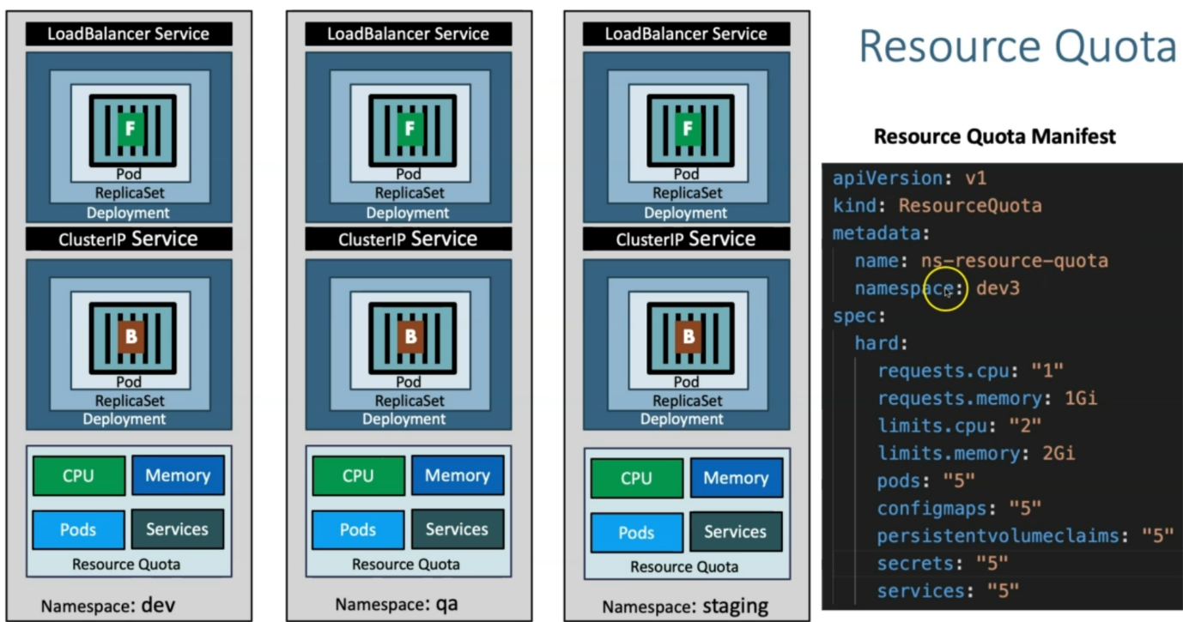--- note – we can limit the resource quota to a name space.

**Create Namespace manifest**

--- **Important Note**: File name starts with 00- so that when creating k8s objects namespace will get created first so it doesn’t throw an error.

apiVersion: v1

kind: Namespace

metadata:

  name: dev3

**Create ResourceQuota manifest**

apiVersion: v1

kind: ResourceQuota

metadata:

  name: ns-resource-quota

  namespace: dev3

spec:

  hard:

    requests.cpu: "1"

    requests.memory: 1Gi

    limits.cpu: "2"

    limits.memory: 2Gi

    pods: "5"

    configmaps: "5"

    persistentvolumeclaims: "5"

    replicationcontrollers: "5"

    secrets: "5"

    services: "5"

--- 00-namespace-LimitRange-ResourceQuota.yml

apiVersion: v1

kind: Namespace

metadata:

  name: dev3

---

apiVersion: v1

kind: LimitRange

metadata:

  name: default-cpu-mem-limit-range

  namespace: dev3

spec:

  limits:

    - default:

        memory: "512Mi" # If not specified the Container's memory limit is set to 512Mi, which is the default memory limit for the namespace.

        cpu: "500m"  # If not specified default limit is 1 vCPU per container

      defaultRequest:

        memory: "256Mi" # If not specified default it will take from whatever specified in limits.default.memory

        cpu: "300m" # If not specified default it will take from whatever specified in limits.default.cpu

      type: Container

---

apiVersion: v1

kind: ResourceQuota

metadata:

  name: ns-resource-quota

  namespace: dev3

spec:

  hard:

    requests.cpu: "1"

    requests.memory: 1Gi

    limits.cpu: "2"

    limits.memory: 2Gi

    pods: "5"

    configmaps: "5"

    persistentvolumeclaims: "5"

    secrets: "5"

    services: "5"

**Create k8s objects & Test**

**# Create All Objects**

--- **kubectl apply -f kube-manifests/**

**# List Pods**

--- **kubectl get pods -n dev3 -w**

**# View Pod Specification (CPU & Memory)**

--- **kubectl get pod <pod-name> -o yaml -n dev3**

**# Get & Describe Limits**

--- **kubectl get limits -n dev3**

--- **kubectl describe limits default-cpu-mem-limit-range -n dev3**

**# Get Resource Quota**

--- **kubectl get quota -n dev3**

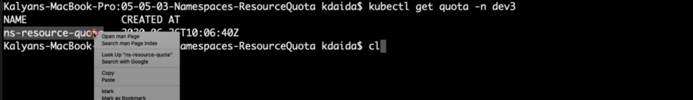

--- **kubectl describe quota ns-resource-quota -n dev3**

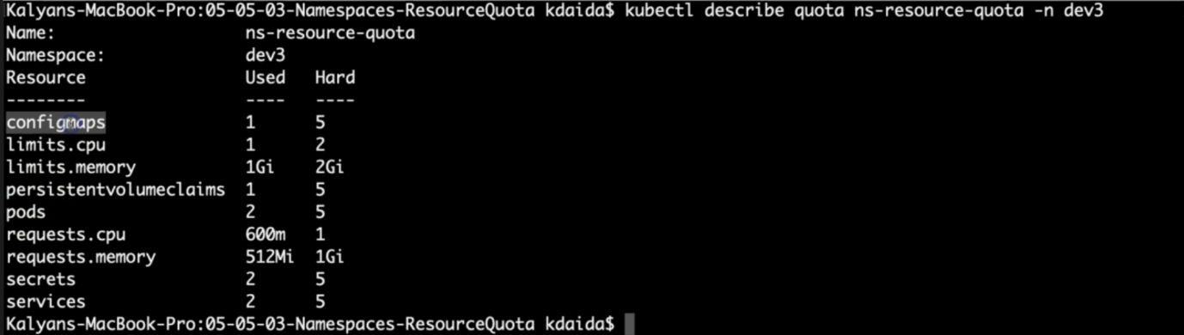

**# Get NodePort**

--- **kubectl get svc -n dev3**

**# Get Public IP of a Worker Node**

--- **kubectl get nodes -o wide**

**# Access Application Health Status Page**

--- **http://<WorkerNode-Public-IP>:<NodePort>/usermgmt/health-status**

**Clean-Up**

--- Delete all k8s objects created as part of this section

**# Delete All**

--- **kubectl delete -f kube-manifests/**